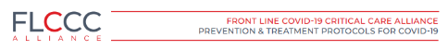
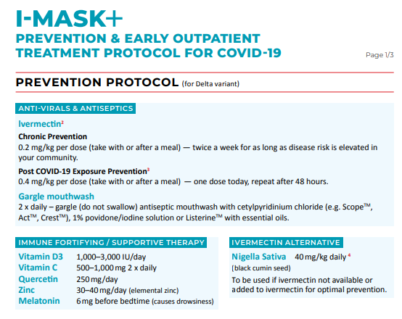
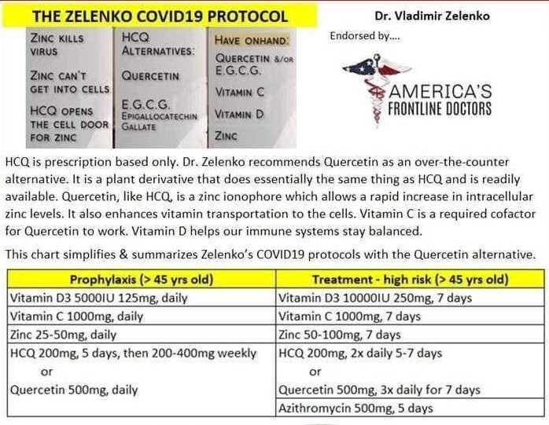
EARLY TREATMENT
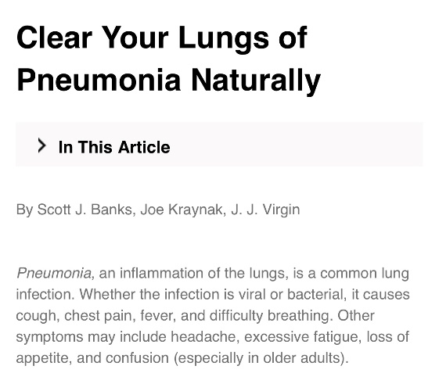
Garlic | 300 mg in capsule form or 5 ml garlic in diluted water,  twice daily
Turmeric | 400 mg daily in capsule form, add as spice to meals,  Or 5 ml turmeric extract diluted in small amt of water
Ginger | 2.5 ml diluted in water or juice or 300 mg in capsule form  2-3 times a day
Oil of Oregano | 5ml mixed with coconut oil & dissolved in mouth  several times a day
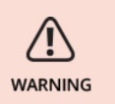
Pneumoni is a major cause of death worldwide and the sixth leading cause of death in the United States. If you have symptoms of pneumonia, consult your doctor.
MEDICAL RESOURCES
If your symptoms do not get better with home remedies or you need medical help, the doctors below are successfully treating viral infections, including covid:
https://americasfrontlinedoctors.org/covid/early-treatment/
https://myfreedoctor.com/ (app download required)
https://covid19criticalcare.com/ivermectin-in-covid-19/how-to-get-ivermectin/
https://pharmacyfinder.rxlocal.com/pharmacyfinder

